1)create repository and give name to that repository and make it public then add

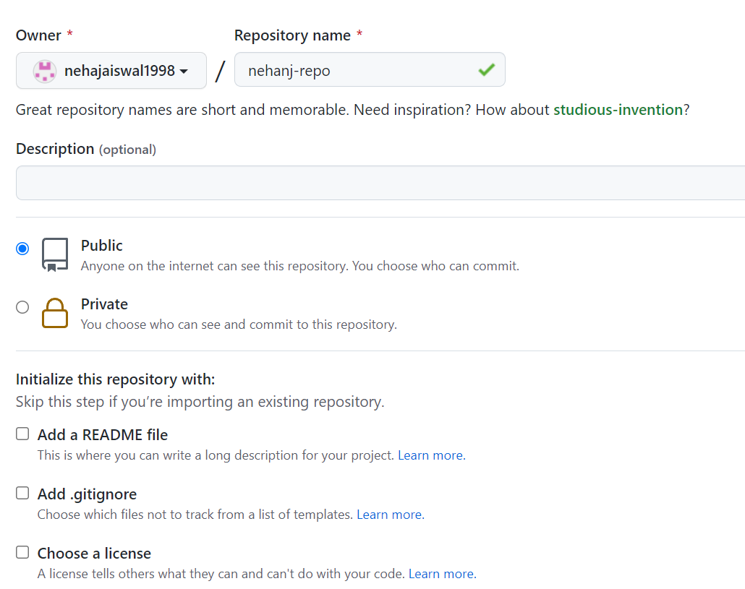

2)Then create a folder on desktop and open gitbash in that folder

And then type ssh-keygen to generate public/private key

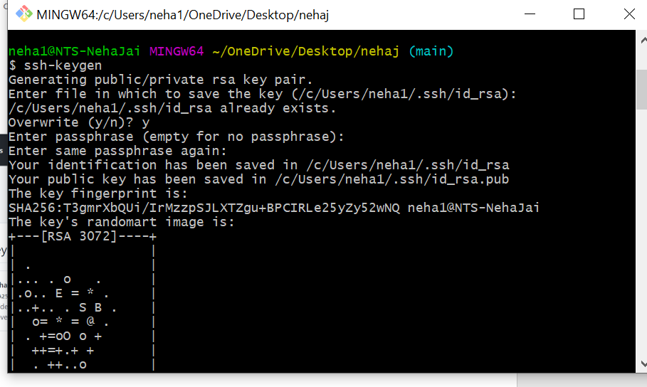

3)then add key in github in deploy keys option

Paste there ssh public key and add

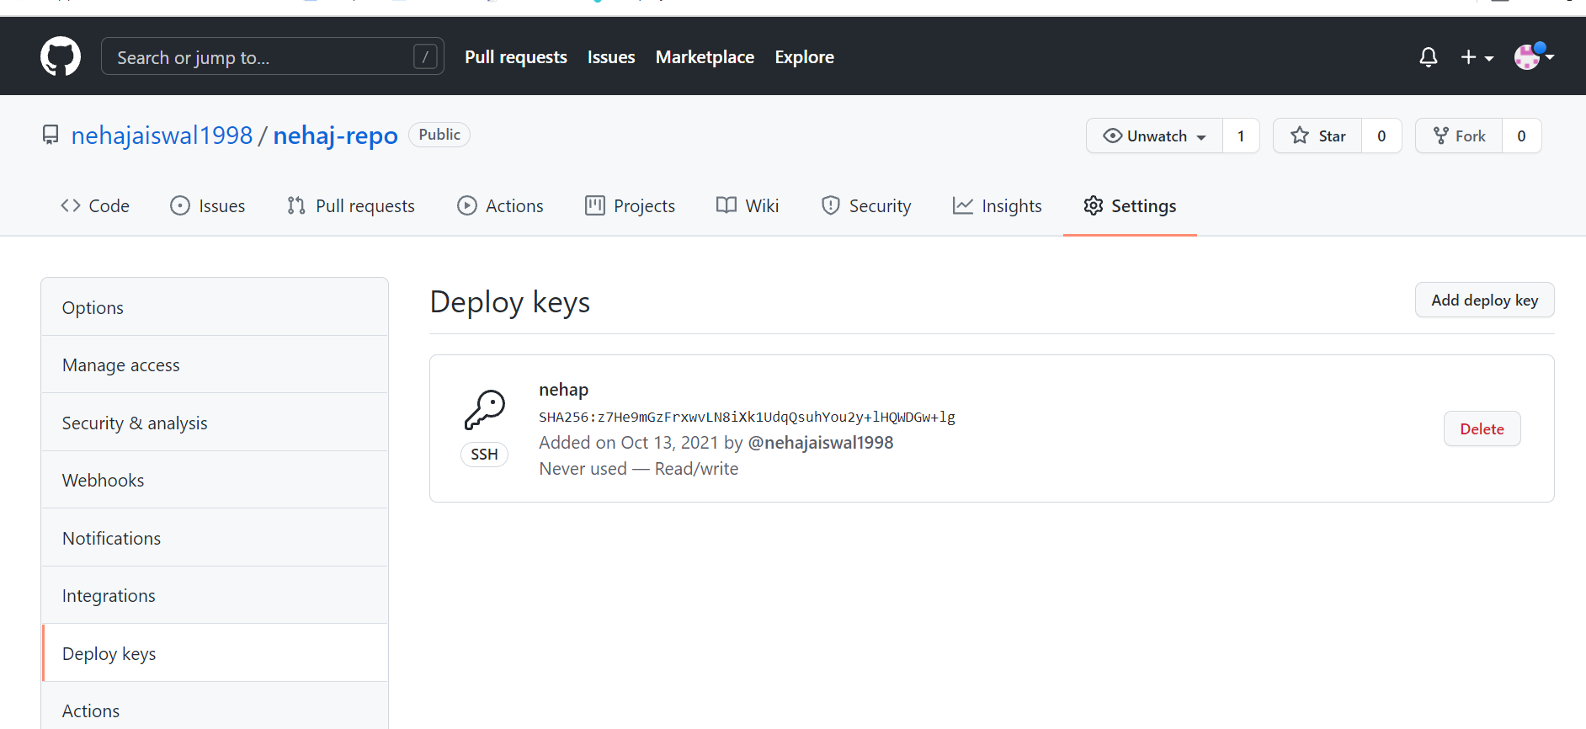

4)perform following commands it will add,commit and puch in github

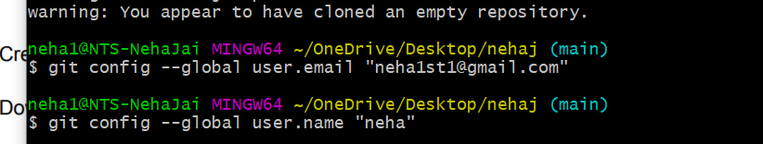

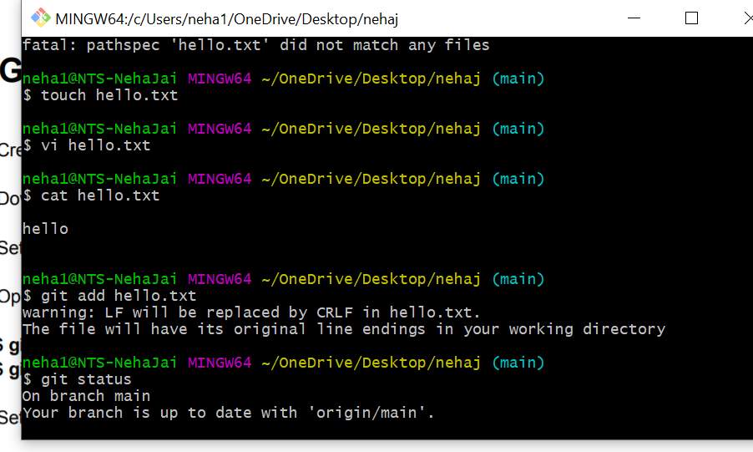

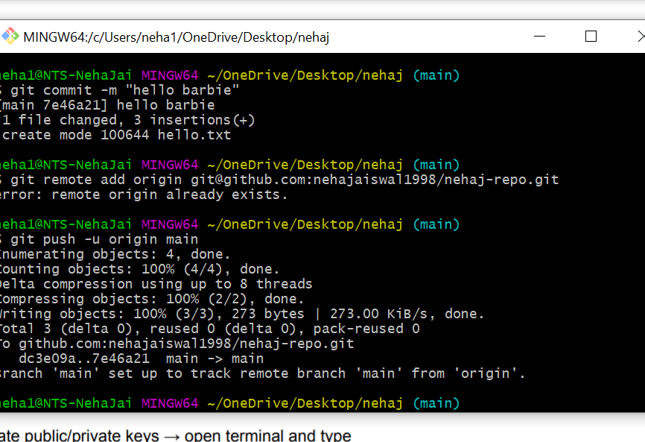

5)then file gets created in github and message will display in it

